Surcharge MicroService – Additional Changes
We have updated our Surcharge Microservice with additional changes
- Include API Key-based authorization using the API-Key header.
- Include CorrelationId using ‘Correlation-ID’ header.

What's Changed: All API calls now require below mandatory request headers to be included in the API request headers
- API-Key
- Correlation-ID
Request Header | Values / Comments
API-Key | Unique API keys have been generated and provided for each consuming team through separate Email. Please using those API Keys.
Correlation-ID | For each API request unique GUID needs to be generated from source team and pass it into request header  Sample format: 01918548-d105-4851-b349-5bc9f1a1f951

- Each distinct API key allows us to track and monitor usage by source/consuming team.
- Correlation Id – Allows to trace request/response flow across multiple services.

Sample Request headers:
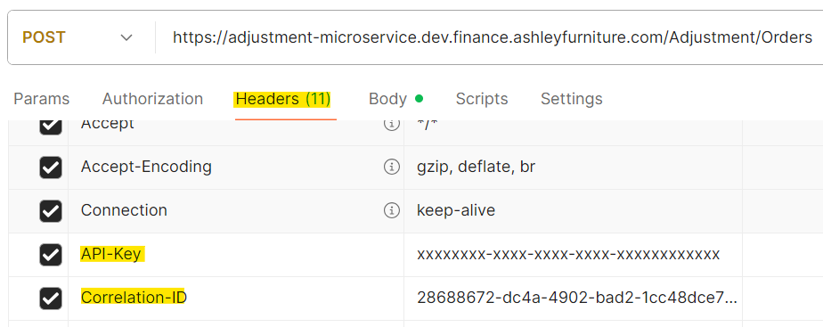

Sample Input Request: (No Recent changes)
{
"orders": [
{
"order_id": "",
"customer_id": 1256500,
"ship_to": "01",
"order_date": "6/16/2025",
"warehouse_id": " ",
"items": [
{
"item_id": "1030125",
"quantity": 2,
"price": 220.32
}
]
}
]
}
Sample Response: (No recent changes with response format)
{
"orders": [
{
"order_id": "",
"customer_id": 1256500,
"ship_to": "01",
"total_surcharge": 0,
"adjustments": [
{
"item_id": "1030125",
"quantity": 2,
"price": 220.32,
"status": "1",
"adjustment_details": []
}
]
}
]
}

